Liaison CS Meeting Agenda – Thursday 10/10/24

1. We want to hear more about justification for labeling from Dr. Cooper. What is the mosquito data labeling process?
2. Discussion of licensing requirements
3. Our steps forward

Minutes

1. How do we find waveform boundaries (Dr. Cooper)

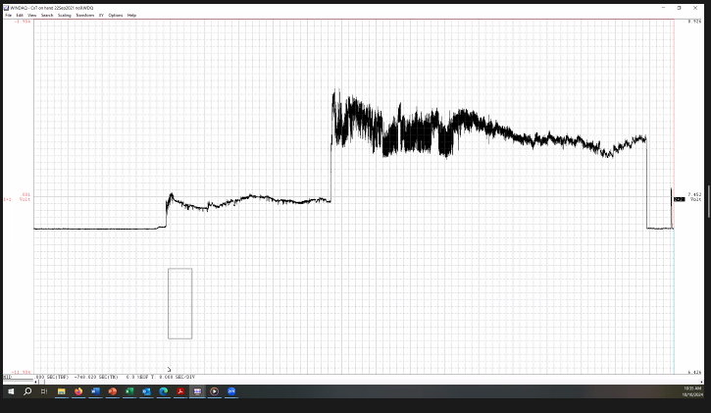

* Finds J at the first voltage rise, knows K is after that. M is the next sharp voltage rise
* J: Finding J is difficult at a compression of 1 but it is more obvious when the compression is higher.
* K: Starts where the signal rises rapidly after J, ends once it starts to drop back down (best visibility at a compression of say 20) and the overall slope changes. At a compression of 1, it is where the high amplitude bumps disappear.
* We know that this one doesn’t have N because of the peak shapes (symettrica)

Another Recording

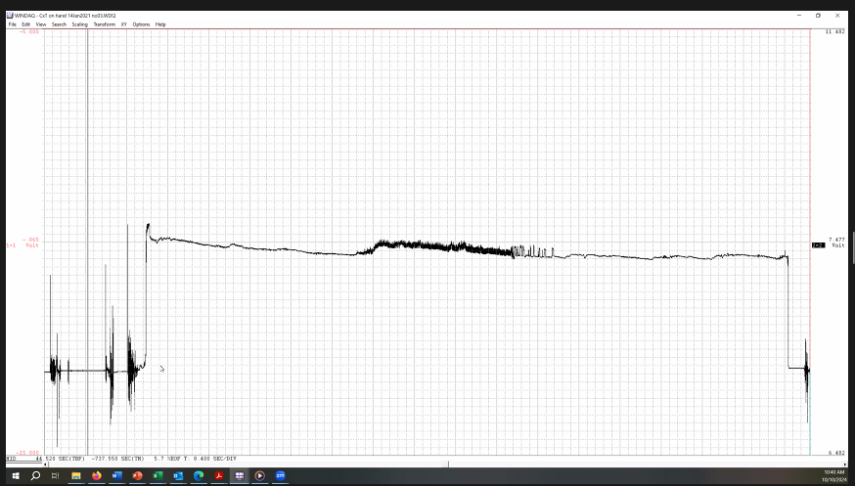

* K is easy to find as it is the first large spike (ignoring the noisy bits at the beginning) and it’s clear where it would end (after the drop)
* With these settings, there is no large voltage spike at M. We can still tell where it is though because the amplitude of the peaks increases and it looks “denser” (this just means higher frequency).
* L and N look very similar at high RI levels.
* N is fairly flat, has large skewed peaks (i.e., not symmetrical peaks)
* The groups of spikes after the dense M section could be either considered M or N, hard to tell and Dr. Cooper would love input on this based on the program’s results

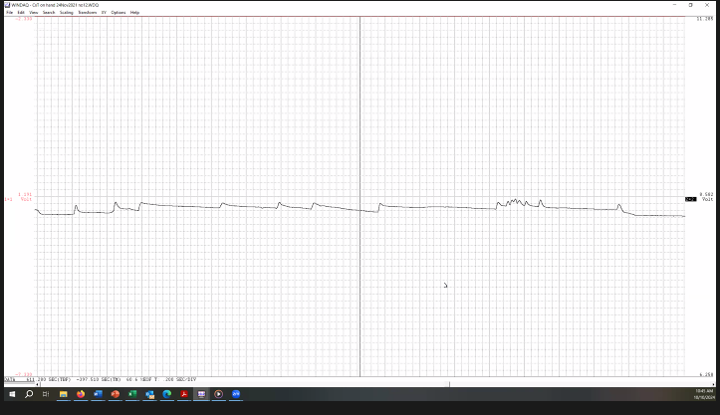

* Examples of skewed peaks characteristic of N
* M is ingestion, each peak is a pump from the mosquito.
* There may be multiple small voltage rises for J, it’s only the last one that results in probing that we care about
* Dr. Backus: Skewed waveforms are possibly due to wire issues / capacitance tails, however there may be a biological explanation as well.
* There can be “pauses” during M (this is called M4).
* The transition between M and N is also characterized by a voltage drop.

Last One

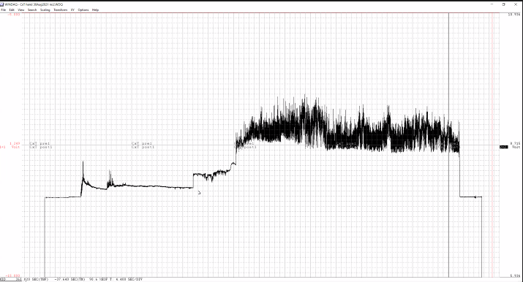

* This one is unique in that the gain was changed so it makes it look like M may have started later, we might need to be able to take this into account
* The “right” place for a transition might look different at different compression levels
* Currently, we only label one K waveform per probe, but it may be possible for there to be multiple Ks (like in the one above).

Good News: There’s more mosquito waveforms out there (61 to be exact, from a new species)

Bad News: We don’t have any records of their scoring.

1. Licensing Requirements

* Mehrezat brought forth the idea that if we want to make use of front end frameworks (specifically Qt) in a final product, we will probably need to buy a commercial license
* Liaisons will consult their people on licensing

Note from Dr. Reif

* Wants brought up the possibility of publication of model results. In particular, she would like to make sure that we compile the results of using all of our models on the *Culex tarsalis* data before we decide to move forward with just one.

1. Updates from the team were minimal, we are continue to work but don’t have anything to present at the moment (also the time for our meeting was up).